Designing and Evaluating an Agentic AI Customer-Support Chatbot
with Human Handover for JumpStart Retail
Research Proposal

1. Introduction
JumpStart Retail operates in an environment where customers expect prompt and consistent assistance before and after an online purchase. Typical enquiries concern product details, size or variant availability, delivery, order progress, returns, refunds, account access and store policies. A conventional frequently asked questions page can answer predictable questions, but it cannot maintain a multi-turn conversation, use account-related context, recognise uncertainty or transfer a difficult case to a member of staff. At the same time, a language model that is allowed to respond without evidence or business controls may provide fluent but incorrect information.
This proposal presents JumpStart AI Support, a controlled, single-agent customer-support prototype for JumpStart Retail. The system will combine an authenticated retail chatbot, Retrieval-Augmented Generation (RAG), approved Django business tools, local sentiment analysis, evidence-based confidence checks and real-time human handover. The chatbot will support routine enquiries, but the application will retain deterministic control over authentication, database access, tool execution, conversation state and escalation. Human staff will handle explicit customer requests, sensitive issues, unresolved conversations and low-confidence cases through a dedicated support dashboard.
The purpose of the study is not to demonstrate that AI can replace customer-service staff. It is to investigate whether a carefully governed hybrid service can improve the support experience by making routine help more accessible while preserving human judgement when automation is unsuitable. Effectiveness will be examined through technical testing, an anonymous questionnaire, exploratory usability testing and optional in-chat feedback.

2. Background and Rationale

2.1 Business Problem
Retail support is difficult to automate because questions vary in clarity, risk and required information. A product-policy question may be answered from approved documents, whereas an order enquiry requires authenticated data. A complaint may begin as a simple request but become emotionally sensitive, and a return or refund discussion may require human discretion. A useful support system must therefore do more than generate text: it must decide whether to retrieve knowledge, use a controlled tool, ask a focused question, refuse an unsupported request or create a human-support case.
The central problem is that AI cannot always be fully trusted. It may retrieve weak evidence, misunderstand a complex request, fail to identify missing information, or present an invented policy with excessive confidence. It may also recognise negative sentiment incorrectly or continue a conversation after the customer has already asked for a person. These limitations create risks to customer trust, privacy, service quality and organisational accountability.

2.2 Rationale for a Hybrid AI-Human Service
A hybrid approach is justified because the strengths of automation and human support are complementary. The AI can provide consistent help for common questions, retrieve approved information and perform safe mock lookups. Human staff can interpret exceptions, exercise judgement, manage emotional conversations and take responsibility for cases that cannot be resolved reliably. In the proposed design, human handover is not an emergency feature added after development; it is a first-class service state with defined triggers, queue management, conversation history, staff assignment and resolution.
The system also has practical business value. It can reduce the repeated effort required for routine questions, preserve context when a case reaches staff, give administrators visibility into weak answers and negative feedback, and support continuous improvement of the knowledge base. The local and cost-effective prototype is appropriate for my capstone project because it integrates web development, databases, vector retrieval, natural-language processing, real-time communication, security, user research and evaluation within a controlled scope.

2.3 Expected Contribution
The expected contribution is a practical and evaluated design for integrating a single stateful AI workflow with grounded knowledge, controlled tools and human support in a small retail environment. The project does not claim to invent RAG, proactive questioning or human-in-the-loop service. Its contribution is the transparent combination of these ideas in one JumpStart-specific prototype with explicit governance rules and evidence from both technical and user-centred evaluation.

3. Research Aim
To design and evaluate an agentic AI customer-support chatbot that provides grounded automated assistance, transfers difficult or sensitive cases to human staff, and improves customer support for JumpStart Retail.

4. Research Objectives
- Investigate modern agentic AI, Retrieval-Augmented Generation and human-in-the-loop approaches for retail customer support.
- Identify customer expectations and concerns through an anonymous online questionnaire.
- Design and develop a chatbot using grounded knowledge retrieval, sentiment analysis, controlled tools and confidence-aware decisions.
- Implement a staff dashboard for urgent human handover, direct customer chat, case resolution, conversation history and administrator monitoring.
- Evaluate answer accuracy and relevance, handover correctness, usability and customer feedback.

5. Research Question

5.1 Main Research Question
“How effectively can an agentic AI customer-support chatbot with human handover improve the customer-support experience for JumpStart Retail?”

5.2 Supporting Research Questions

1. How can RAG and agentic clarification improve the accuracy and relevance of chatbot responses?
- What will be investigated: How RAG retrieves reliable information and how clarification questions improve understanding of unclear requests.
- Why it is important: Accurate and relevant responses increase customer trust and reduce incorrect answers.
- Contribution to the overall aim: It evaluates the chatbot’s ability to provide effective automated support.

2. Under what conditions should the chatbot transfer a conversation to human staff?
- What will be investigated: Handover triggers such as customer requests, low confidence, repeated misunderstanding, complex issues and unavailable information.
- Why it is important: Correct handover prevents poor responses while avoiding unnecessary transfers.
- Contribution to the overall aim: It evaluates how effectively AI and human-support staff work together.

3. How effectively does the proposed prototype meet user expectations for accuracy, handover correctness, usability and feedback?
- What will be investigated: User opinions about response quality, handover timing, ease of use, system feedback and overall satisfaction.
- Why it is important: A technically functional chatbot must also be useful, understandable and trusted by users.
- Contribution to the overall aim: It provides evidence of whether the prototype delivers a satisfactory customer-support experience.

6. Literature Review

6.1 Introduction and Review Scope
The literature review focuses on three recent studies selected because they map directly to the main design challenges of JumpStart AI Support: retrieving reliable knowledge from noisy information, asking useful questions when information is missing, and deciding how human intervention should operate when an agentic AI system fails. The papers are treated as design evidence rather than complete solutions to be copied. Each study is reviewed critically by considering its contribution, the lesson applied to the current project, and the way the proposed prototype differs from the original research.
All three sources are 2026 arXiv preprints. They provide current technical and operational evidence, but their recent preprint status means that their findings should be applied cautiously. The project will therefore use their principles as starting points and test the resulting design in the JumpStart Retail context.

6.2 Overview of Agentic AI Customer Support
An agentic customer-support application differs from a single-response chatbot because it maintains state and selects a controlled next action. For this project, agentic behaviour means that one LangGraph workflow can interpret the request, plan an approved route, retrieve knowledge or call a permitted business tool, verify the result, and route the conversation to an answer, a clarification, a safe refusal or a human-support case. It does not mean unrestricted autonomy, direct model access to the database, or multiple independent agents.
The three selected studies collectively show that dependable support requires more than a capable language model. Retrieval quality affects factual reliability; question timing affects the efficiency and acceptability of multi-turn dialogue; and the timing and type of human intervention affect service outcomes. These findings support a system architecture in which language generation is separated from deterministic application control.

6.3 Han et al. (2026): Structure-Aware RAG
Han et al. (2026) address a common weakness in RAG systems: the retriever may return noisy, irrelevant or weakly structured context. Their Structure-Aware RAG approach uses tables as an intermediate representation and adds quality-aware metadata so that retrieval is more compact and controllable. The authors report that the approach outperformed existing RAG baselines on two noisy real-world conversational datasets. The study demonstrates that knowledge organisation and metadata quality are as important as the language model used to produce the final answer.

6.3.1 What I Learned and Will Apply
I learned that simply splitting documents into text chunks and storing embeddings is not enough to guarantee useful retrieval. For JumpStart AI Support, I will retain source identity, document status, topic, policy type and other metadata for every approved knowledge chunk. Administrators will preview and approve imported content before it becomes searchable. Retrieval results will be checked for relevance and source support, and weak retrieval will lead to clarification, refusal to guess or human handover rather than an invented policy answer.

6.3.2 How My Project Differs
My project will not reproduce the complete SA-RAG research pipeline, convert every document into generated tables, or train a metadata-generation model. Those activities would be too large for the four-week capstone. Instead, the prototype will implement a lighter PostgreSQL and pgvector design using approved chunks, structured metadata and retrieval testing. The differentiation is the integration of this practical RAG approach with authenticated retail tools, confidence checks, customer-requested handover and a staff dashboard.

6.4 Huang et al. (2026): PROCHATIP
Huang et al. (2026) propose PROCHATIP, a framework that learns when a customer-service chatbot should proactively probe for target information. The study separates the decision to probe from response generation and trains a lightweight conversation-strategy module through supervised fine-tuning and reinforcement learning. Compared with the strongest baseline, the authors report an 11.36% improvement in successful target-information collection, 39.50% fewer conversation turns and a 23.73% improvement in overall user satisfaction. The important principle is that a chatbot should not ask questions continuously; it should ask at the right time and stop when a probe becomes intrusive or unhelpful.

6.4.1 What I Learned and Will Apply
I learned that clarification should be targeted and governed by conversation state. JumpStart AI Support will identify the minimum information required for the current retail task and ask a focused question only when that information is missing. The workflow will allow a maximum of two clarification attempts. If the conversation remains unresolved, the system will offer human support rather than repeatedly asking the same question.

6.4.2 How My Project Differs
PROCHATIP is designed to harvest pre-specified business intelligence while balancing user friction. My project does not use customer-support conversations to collect unrelated commercial intelligence, and it will not train a separate probing model with reinforcement learning. Clarification is used only to resolve the customer's support request, for example obtaining an order reference or identifying the product involved. This narrower purpose reduces privacy risk and keeps the project aligned with customer service rather than data extraction.

6.5 Wang et al. (2026): Agentic AI and Human-in-the-Loop Intervention
Wang et al. (2026) study an agentic AI system through a randomised field experiment in Alibaba's customer-service operations. The study reports that AI reduced average chat duration and had limited effects on retrial rates, but ratings for AI-eligible chats were substantially lower. Human intervention was more successful for technical escalations than for emotional escalations, and early intervention was important for maintaining staff effort after escalation. The findings show that handover is not automatically effective; service quality depends on why the case was escalated, when staff intervene and how actively they continue the conversation.

6.5.1 What I Learned and Will Apply
I learned that the handover mechanism must preserve context and encourage early staff action. JumpStart AI Support will place urgent cases at the top of the queue, send real-time visual and sound alerts, provide the handover reason and preserve the conversation history. Strong negative sentiment will not be treated as a simple automatic trigger; it will be combined with another factor such as low confidence, repeated failure or issue sensitivity. This reflects the study's distinction between technical and emotional escalations.

6.5.2 How My Project Differs
The Alibaba study evaluates a large operational deployment, whereas my work is a small local prototype with exploratory participants. My project also provides a visible Talk to Human Staff control so that a customer does not have to wait for an algorithm to recognise failure. It uses two separate routes: immediate Django-validated explicit handover and AI-triggered handover after controlled evaluation. The project will evaluate whether those rules work correctly, but it will not claim the statistical generalisability of a commercial field experiment.

6.6 Comparative Learning and Project Differentiation
Selected paper | Main learning used in JumpStart AI Support | How the current project is different
Han et al. (2026) | Use approved knowledge, metadata, source tracking and relevance checks to reduce noisy retrieval. | Uses a practical chunk-and-metadata pgvector implementation rather than the full table-generation and training pipeline; connects RAG to retail tools and human handover.
Huang et al. (2026) | Ask focused questions only when necessary and control when clarification should stop. | Uses clarification only for the customer's immediate support need; no reinforcement-trained probing module and no unrelated business-intelligence harvesting.
Wang et al. (2026) | Intervene early, preserve context, distinguish technical from emotional escalation, and design the staff process as carefully as the AI. | A local, small-sample prototype with both a visible customer CTA and deterministic AI-triggered escalation rather than a large commercial field experiment.

6.7 Benefits and Opportunities Identified in the Literature
- Grounded retrieval can make support answers more controllable and easier to update than relying only on model parameters.
- Targeted clarification can collect the missing information needed to complete a support task while reducing unnecessary turns.
- A planned human-in-the-loop process can protect service quality when an AI system reaches the boundary of its capability.
- Combining these ideas may support a service that is available for routine questions without hiding uncertainty or removing human accountability.
- Conversation logs, feedback and retrieval metadata can help administrators identify weak knowledge and improve the service over time.

6.8 Challenges and Limitations
` The literature also demonstrates that no individual technique guarantees reliable service. RAG can still retrieve irrelevant or outdated information. Proactive questioning can frustrate users when the timing or purpose is inappropriate. Human handover may occur too late, and staff may respond differently to technical and emotional cases. The three selected sources are recent preprints, use different datasets and organisational contexts, and do not evaluate the exact combination proposed for JumpStart Retail.
These limitations justify the project's controlled implementation. Retrieval will use approved sources, tool access will be allow-listed, confidence will be based on measurable evidence, clarification will be limited, and staff will remain accessible. The evaluation will report both successful and unsuccessful cases rather than treating the prototype as production-ready.

6.9 Ethical Considerations from the Literature
The selected findings create several ethical responsibilities. Customers should be told that they are communicating with AI, should not be pressured to disclose unrelated information, and should have a clear route to a person. Personal and account information must be minimised and protected. Monitoring should be limited to what is needed for support, security and evaluation. The system must not store hidden chain-of-thought, allow the language model unrestricted access to the database, or perform real financial actions without appropriate human and organisational controls.

6.10 Research Gap and Summary
The reviewed studies focus separately on structured retrieval, proactive probing and human intervention. They do not provide a complete, cost-effective small-retail prototype that combines these elements with authenticated Django tools, a visible customer handover control, real-time staff chat, administrator knowledge approval and mixed technical/user evaluation. JumpStart AI Support addresses this practical gap by integrating the most relevant principles in one transparent single-agent architecture and evaluating where automation is useful and where it should defer to staff.

7. Research Methodology

7.1 Methodology Overview
The study will use the Saunders Research Onion as an organising framework. The selected methodology is pragmatic, deductive, mixed-method, case-study based and cross-sectional. It is designed to evaluate both the technical operation of the prototype and the way potential users understand and experience the proposed hybrid service.

7.2 Saunders Research Onion
Layer | Selected decision | Reason for selection
Research philosophy | Pragmatism | The project addresses a practical retail-support problem and accepts both technical measurements and participant experience as useful evidence.
Research approach | Deductive | Ideas from recent research are translated into design rules and then examined through implementation and testing.
Methodological choice | Mixed methods | Closed questionnaire data and technical results are combined with optional comments and usability observations.
Research strategy | JumpStart Retail case study | The system, requirements and evaluation scenarios are bounded by one retail context.
Time horizon | Cross-sectional | Data is collected during a limited capstone period rather than through a long-term operational study.

7.3 Research Philosophy: Pragmatism
Pragmatism is appropriate because the research is driven by a practical question: whether a controlled agentic chatbot with human handover can provide useful support in the JumpStart Retail context. A purely positivist design would emphasise only measurable system outcomes, while a purely interpretive design would focus mainly on participant meaning. The project requires both. Technical tests are needed to establish whether the software behaves correctly, and participant evidence is needed to understand clarity, trust, usability and acceptance.

7.4 Research Approach: Deductive
The approach is deductive because the design begins with principles drawn from the three selected studies. Structured and metadata-aware knowledge should improve retrieval quality; focused clarification should reduce unnecessary dialogue; and early, context-preserving human intervention should protect difficult cases. These principles are translated into system requirements and acceptance tests. The results will then be used to determine whether the proposed implementation supports the main research question.

7.5 Methodological Choice: Mixed Methods
Quantitative evidence will include questionnaire frequencies and percentages, answer-quality scores, handover test outcomes and structured usability ratings. Qualitative evidence will include optional questionnaire comments and observations recorded while three participants complete realistic support tasks. Combining these forms of evidence reduces the risk of judging the system only by technical success or only by subjective opinion.

7.6 Research Strategy and Time Horizon
The case-study strategy focuses the investigation on JumpStart Retail, its proposed users, its policies and its demonstration data. The study is cross-sectional because questionnaire responses, prototype tests and usability observations will be collected within the project period from 29 June to 29 July 2026. Long-term repeat use, production workload and commercial performance are outside the available timeframe.

7.7 Primary Research: Anonymous Questionnaire
An anonymous Google Forms questionnaire will be distributed to approximately 20-30 genuine participants. The intended participant mix includes online shoppers, students, classmates, friends, family members and suitable social or messaging groups. The questionnaire is designed to identify expectations and concerns rather than to collect personal profiles.
Questionnaire element | Confirmed design
Consent | One required statement confirming voluntary, anonymous participation for academic purposes.
Background questions | Two non-identifying questions relevant to online-shopping or chatbot experience.
Closed/rating questions | Eleven questions about usefulness, trust, accuracy, privacy, human handover, feedback and willingness to use the service.
Open response | One optional comment question for concerns or suggestions.
Personal identifiers | Names, email addresses, telephone numbers and other direct identifiers will not be requested.

7.8 Exploratory Usability Testing
Three genuine participants will complete an exploratory usability test. The sample is intentionally small and will not be described as representative. It is suitable for identifying obvious interface, navigation and handover problems before the final evaluation.
Task | Expected participant activity | Observation focus
1. Product or policy question | Ask about a product, availability or an approved retail policy. | Clarity of starting a chat, relevance of the answer and source-grounded behaviour.
2. Mock order status | Use an authenticated demonstration order. | Understanding of account context and controlled tool use.
3. Return or refund guidance | Ask a policy-based question that may require clarification. | Quality and number of follow-up questions.
4. Human handover | Use the visible CTA or enter a direct request for a person. | Visibility, speed and clarity of the state change.
5. Staff conversation | Exchange messages with a support staff user. | Continuity of context and recognition of the human responder.
6. Resolution and feedback | End the case and provide optional thumbs-up/down feedback. | Ease of closure and feedback submission.

Response speed will be observed operationally if problems occur, but it is not a formal research metric. This avoids drawing conclusions from local hardware or internet latency that may not reflect the quality of the design.

7.9 Secondary Research Method
Secondary research will use the three selected 2026 academic papers. Search and verification will use Google Scholar where appropriate and the official arXiv records for titles, authors, versions and reported findings. Each paper will be analysed by research problem, method, result, limitation, lesson for JumpStart and project differentiation. No source will be treated as direct proof that the proposed prototype is effective before it is tested.

7.10 Data Analysis
Closed questionnaire responses will be analysed through frequencies and percentages. Bar charts will be the main visual method, while pie charts will be limited to simple binary questions where they improve understanding. The analysis will include a brief interpretation connected to the research objectives rather than presenting charts without explanation.
Optional comments and usability observations will be analysed through concise thematic analysis. Similar points will be grouped into themes such as trust, answer clarity, privacy, handover visibility and interface difficulty. The three-person usability test will be reported as exploratory evidence and will not be used to make broad population claims.

7.11 Technical Evaluation Plan
Evaluation area | Planned evidence | Success interpretation
Answer accuracy and relevance | Representative product, policy, mock-order and account-support scenarios reviewed against approved data. | The answer addresses the request, uses the correct source/tool and avoids unsupported claims.
Grounding and retrieval | Retrieved chunks, metadata and sources inspected for relevance. | Relevant approved evidence is present, or the system clarifies/refuses/escalates instead of guessing.
Handover correctness | Explicit request, low confidence, repeated failure, sensitive case and tool-failure tests. | Correct cases escalate, unnecessary escalation is avoided, and the reason/state is recorded.
Real-time support workflow | Queue alert, atomic first acceptance, staff chat, return to AI and resolution tests. | Only one staff member accepts a case; AI pauses during human states; history remains complete.
Usability and feedback | Three-participant tasks, structured ratings and optional feedback. | Participants can understand the interface and complete the intended workflow with limited assistance.

7.12 Methodology Justification and Alternatives
The methodology is proportionate to the capstone. A questionnaire alone would identify expectations but could not prove that the prototype works. Technical tests alone would show system behaviour but would not reveal whether users understand the handover or trust the service. A large experiment, longitudinal study or commercial field deployment would provide stronger generalisability, but these approaches are not feasible within the four-week implementation period and would require a production service, a much larger sample and organisational approval.
Interviews were considered but not selected as the main primary method because they would require more recruitment, transcription and analysis than the project schedule allows. The anonymous questionnaire produces comparable responses from a wider group, while the small usability test provides direct behavioural observations. The combined method therefore gives a practical balance of breadth, depth and feasibility.

7.13 Ethical Considerations
- Participation will be voluntary, and the questionnaire will begin with a clear consent statement.
- No names, email addresses, phone numbers or unnecessary personal identifiers will be collected for the research questionnaire.
- Questionnaire responses will be used only for academic analysis and reported in aggregate form.
- The chatbot will clearly disclose that it is an AI service and will provide a visible route to human support.
- Authenticated data, conversation history and feedback will be accessible only according to role-based permissions.
- Groq API credentials will be stored in protected environment variables and will not be exposed to the browser or source repository.
- The model will not receive unrestricted database access, arbitrary code execution or authority to perform real payments, refunds or cancellations.
- Prompt-injection attempts, unsupported requests and weak evidence will be handled through validation, tool allow-lists, safe refusal and human oversight.
- The system will not store hidden chain-of-thought or use invasive monitoring such as keystroke and mouse tracking.

8. Proposed System Design and Technical Approach

8.1 Scope and System Boundaries
JumpStart AI Support will be developed as a locally hosted Windows 11 prototype. Visitors may browse the retail website, register and log in. The AI chatbot, conversation history and human-support functions require an authenticated customer account because the service may use mock order information and store support history. The system will support English text chat only during this time.
Included in the prototype | Simulated or future capability
Product and policy questions; approved RAG knowledge; product/variant availability; mock order status; return and refund guidance; account help. | Real payments, refunds, compensation, order cancellation, address changes, courier systems and nationwide live inventory.
Single-agent LangGraph workflow; local sentiment; deterministic confidence; explicit and AI-triggered handover. | Multi-agent orchestration, automatic staff assignment and commercial AI operations.
Real-time staff queue and customer-staff messaging; administrator monitoring and knowledge approval; optional feedback. | Multilingual support, attachments, large-scale analytics and production contact-centre integration.
Local demonstration through multiple browser profiles/devices on the same network. | Public production hosting and production scalability claims.

8.2 Overall System Architecture
Figure 1 presents the complete high-level architecture selected for the proposal. It shows the separation between browser interfaces, deterministic application control, the single-agent workflow, AI and knowledge services, human-support services, the data layer and the external Groq inference service.
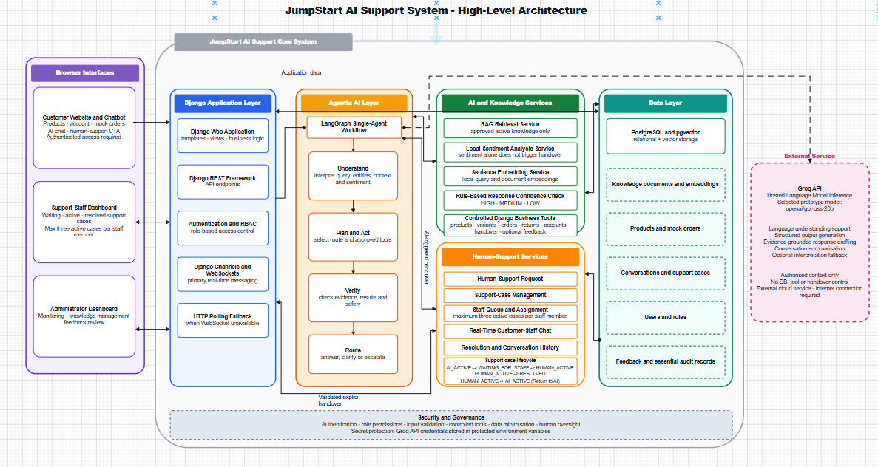
Figure 1. JumpStart AI Support System - High-Level Architecture

8.2.1 Explanation of Figure 1
Architecture explanation
The left side contains three browser interfaces: the customer website and chatbot, the support staff dashboard and the administrator dashboard. All application requests pass through the Django application layer, which is responsible for authentication, role-based access control, API endpoints and real-time WebSocket communication. HTTP polling every two to three seconds is retained only as a fallback when WebSockets are unavailable.
The agentic AI layer contains one LangGraph workflow with four conceptual stages: Understand, Plan and Act, Verify, and Route. The workflow may use the approved RAG retriever, a controlled Django business tool, or both. The external Groq service provides language understanding and response drafting only from authorized context; it has no direct database, business-tool or handover control.
Two independent human-handover paths are represented. A validated explicit handover travels directly from the Django application to Human-Support Services when the customer selects the CTA or clearly asks for a person. An AI-triggered handover travels from the LangGraph workflow when deterministic routing identifies low confidence, repeated failure, a sensitive issue or an appropriate tool failure. The AI pauses while a conversation is waiting for staff or actively handled by staff.
PostgreSQL and pgvector hold users, products, mock orders, conversations, support cases, feedback, audit records, knowledge documents and vector embeddings. Security and governance form a foundation across the system through authentication, minimum data collection, controlled tools, input/output validation, human oversight and protected API credentials.

8.3 High-Level Use-Case Model
Figure 2 defines the main actors and the capabilities available to each role. The proposal intentionally uses three operational roles - customer, support staff and administrator - while treating a visitor as a pre-authentication actor.
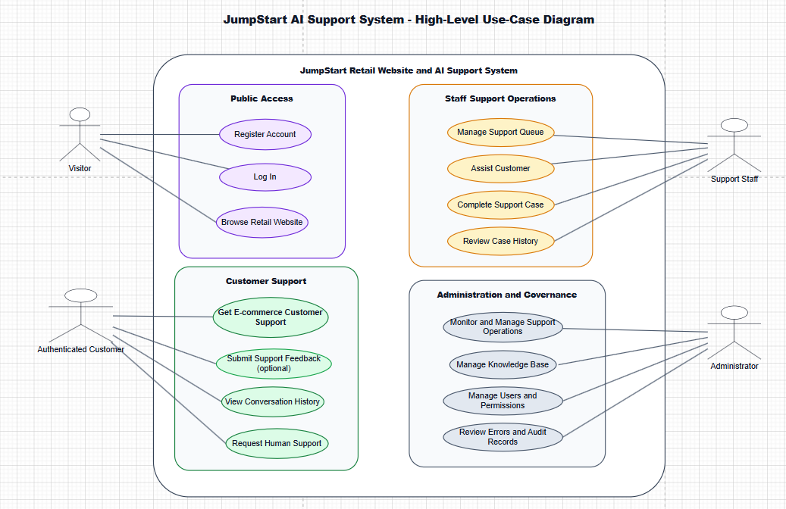
Figure 2. JumpStart AI Support System - High-Level Use-Case Diagram

8.3.1 Explanation of Figure 2
Use-case explanation
A visitor can browse the retail website, register an account and log in. The visitor cannot open the support chatbot because conversation history, mock order tools and human-support cases require an authenticated identity.
An authenticated customer can request e-commerce support, view conversation history, request a human member of staff and submit optional feedback after resolution. The broad support use case includes product and policy questions, mock order enquiries, return guidance, account help, clarification and safe escalation.
Support staff manage the waiting queue, accept a case, assist the customer through real-time chat, complete the case and review resolved history. Assignment is manual and atomic: only the first valid acceptance succeeds, and each staff member may manage a maximum of three active cases.
Administrators monitor support operations, manage the approved knowledge base, manage users and permissions, and review essential errors and audit records. Supervisor-like permissions may be granted to selected staff for workload review and reassignment, but the proposal does not create a separate supervisor actor or dashboard.

8.4 Front-End Technologies and User Experience
The front end will use Django templates, Tailwind CSS, HTMX, Alpine.js and JavaScript. This combination supports a responsive interface without the additional complexity of a separate single-page application. Tailwind CSS will provide consistent spacing, contrast and responsive layouts; HTMX will update partial page content; Alpine.js will manage small interactive states; and JavaScript will handle WebSocket events, sound alerts, typing indicators and fallback behaviour.
The customer chat will follow a familiar messenger pattern with message bubbles, timestamps, sender labels, conversation status, a fixed input area and a visible Talk to Human Staff control. The interface must clearly distinguish AI messages from staff messages. The support dashboard will provide waiting, active and resolved views, while the administrator dashboard will prioritise monitoring, knowledge approval and feedback review.

8.5 Back-End and API Technologies
Django will provide the main application framework, authentication, permissions, business rules and server-rendered interfaces. Django REST Framework will expose controlled endpoints where asynchronous or structured client interaction is useful. Sensitive actions will be validated in Django rather than delegated to the language model. The backend will also enforce ownership checks so that customers can access only their own conversations, mock orders and feedback.

8.6 Single-Agent Agentic Workflow
The workflow will be implemented with LangGraph and LangChain integrations. A conversation state record will persist the current status, interpreted intent, required information, clarification count, selected evidence, tool result, sentiment result, confidence band and handover reason. The persistent service states are AI_ACTIVE, WAITING_FOR_STAFF, HUMAN_ACTIVE and RESOLVED.
Workflow stage | Main responsibility
Understand | Validate the message, identify intent and entities, inspect conversation context and determine what information is missing.
Plan and Act | Select RAG, an approved Django tool, both, or a focused clarification.
Verify | Check source relevance, tool success, required-data completeness and whether the proposed answer is supported.
Route | Return an answer, ask a clarification, safely refuse, regenerate once, or create a human-support case.

The workflow will permit no more than two clarification attempts and one response-regeneration attempt. A regenerated response must be verified again. These limits prevent an endless automated loop and make the transition to human support predictable.

8.7 RAG and Knowledge-Base Design
Administrators will be able to add, update, disable, approve and reject knowledge. Supported import formats are PDF, DOCX, TXT and CSV. Uploaded content will pass through validation, extraction and preview before approval. Only approved information will be cleaned, chunked, assigned metadata, embedded locally and stored in PostgreSQL with pgvector.
The exact Sentence Transformers model, vector dimension, chunk size, overlap, top-k value, distance metric and relevance threshold will be selected through realistic retail-support tests. This is preferable to fixing arbitrary values in the proposal. Source metadata and document status will be retained so that answers can be traced and outdated material can be disabled.

8.8 Sentiment, Confidence and Human Handover
A compact local Hugging Face model will provide primary sentiment analysis. Text preparation will validate input and normalise Unicode and whitespace while preserving punctuation, emojis and meaningful wording. The main language-model service is Groq, while sentiment and embeddings remain local.
Sentiment alone will not create a handover. Strong negative sentiment will contribute only when another condition is present, such as low answer confidence, repeated failure, issue sensitivity or tool failure. Answer confidence will use deterministic HIGH, MEDIUM and LOW bands based on retrieval relevance, source support, tool success, data completeness and verification results rather than a language model's self-reported certainty.
Handover route | Trigger and behaviour
Validated explicit handover | A typed request or visible CTA is validated by Django and creates a support case immediately without RAG or Groq processing.
AI-triggered handover | LangGraph routes the case when measurable evidence shows low confidence, repeated failure, a sensitive issue or an appropriate tool failure.
Waiting and active states | AI output pauses in WAITING_FOR_STAFF and HUMAN_ACTIVE. The same conversation and context are preserved for staff.
Return to AI | A staff member may use a separate action to move HUMAN_ACTIVE back to AI_ACTIVE without resolving the conversation.

8.9 Staff Dashboard and Real-Time Chat
Urgent waiting cases will appear at the top of the support queue and create visual and sound notifications for available staff. A staff member will select Accept Case, and an atomic database update will ensure that only the first valid acceptance succeeds. After acceptance, the status update will remove or update the notification for other staff in real time. Each staff member may hold a maximum of three active cases.
Django Channels and WebSockets will be the primary transport for customer-staff messages, queue updates, typing states and case status changes. HTTP polling every two to three seconds will be available as a fallback. Staff can resolve a case or return it to AI. Resolution preserves the messages in the customer history and staff Resolved/History view, and it makes optional feedback available to the customer.

8.10 Administrator Monitoring and Customer Feedback
The administrator dashboard will provide proportionate oversight rather than invasive surveillance. It will allow authorised users to review conversation histories, detected intent, sentiment, confidence bands, retrieved sources, controlled tool actions, handover reasons, staff replies, errors and feedback. Negative feedback can be linked to the relevant conversation so that administrators can determine whether the issue came from knowledge, AI routing, a tool or human handling.
Feedback will be optional and displayed after resolution. The basic mechanism will use thumbs up or thumbs down. A negative response may include an optional reason and short comment. The system will automatically identify whether the support path was AI_ONLY, AI_AND_HUMAN or HUMAN_ONLY, enabling simple comparison without asking the customer to classify the interaction.

8.11 Database and pgvector Design
PostgreSQL will provide both relational application storage and vector storage through pgvector. Core relational areas will include users and roles, customer profiles, products and variants, mock orders and order items, chat sessions, messages, support cases, staff assignments, feedback, knowledge documents, knowledge chunks, agent actions and essential error/audit records. Foreign keys and transaction boundaries will protect consistency, especially during first-accept case assignment and conversation-state changes.
Vector embeddings will be associated with approved knowledge chunks rather than stored as an unrelated index. Each chunk will retain its source document, metadata, approval status and update information. This design supports retrieval while allowing an administrator to disable a document and prevent its chunks from being used.

8.12 Security and Governance
- Authentication and role-based access control for customer, support staff and administrator functions.
- Server-side ownership and permission checks for conversations, mock orders, support cases and feedback.
- Tool allow-lists and parameter validation; the language model cannot execute arbitrary code or query the database directly.
- Minimum authorised context sent to Groq; protected environment variables for API credentials.
- Knowledge approval, source metadata and disabling of outdated content.
- Prompt-injection and unsafe-input tests, output validation and safe refusal when instructions conflict with system rules.
- Clear AI disclosure, visible human access and human oversight for sensitive or low-confidence situations.
- No collection of hidden chain-of-thought and no invasive user monitoring.

8.13 Local Deployment and Cost-Effective Implementation
The prototype will be implemented, tested and demonstrated on the existing Windows 11 laptop. Django, PostgreSQL, pgvector, the embedding model and the sentiment model will run locally. Groq API will remain an external hosted inference service and will require an internet connection and protected API key. Customer, staff and administrator views can be demonstrated using separate browser profiles or devices on the same local network.
The design is cost-effective because it uses open-source frameworks and existing hardware, avoids a separate vector database, and uses mock data for commercial features. GitHub will provide source control, Postman will support API testing and Draw.io will be used for the diagrams. Public cloud deployment remains a future enhancement and will not be presented as completed work.

9. Work Breakdown Structure
The Work Breakdown Structure divides the project into eight manageable work packages. It covers both the academic research and the implementation evidence required for the final capstone submission.
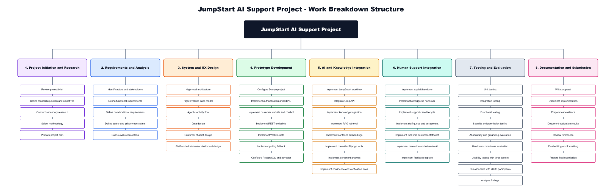
Figure 3. JumpStart AI Support Project - Work Breakdown Structure

9.1 Explanation of Figure 3
WBS explanation
Work packages 1 and 2 establish the academic and requirements foundation by reviewing the brief, defining the research question, selecting the methodology, identifying actors and specifying functional, non-functional, safety and privacy requirements.
Work package 3 produces the architecture, use-case model, data design and interface plans. Work package 4 creates the Django prototype, authentication, customer interface, APIs, WebSockets, polling fallback and PostgreSQL/pgvector environment.
Work packages 5 and 6 implement the AI and human-support capabilities. These include LangGraph, Groq, knowledge ingestion, RAG, embeddings, sentiment, controlled tools, confidence rules, explicit and AI-triggered handover, queue management, staff chat, resolution, return to AI and feedback capture.
Work packages 7 and 8 provide evidence and completion activities: functional, integration, security, accuracy, grounding, handover and usability tests; questionnaire analysis; implementation documentation; evaluation; reference checking; final formatting and submission. The WBS demonstrates that documentation and evaluation are continuous project outputs rather than tasks left until the final day.

10. Project Schedule
The proposal is submitted on 26 June 2026. Development begins on 29 June 2026 and is organised into four main weeks, followed by a three-day closeout period ending with final submission on 29 July 2026. The schedule deliberately places core architecture and data work before AI integration, and completes the human-support path before final evaluation.
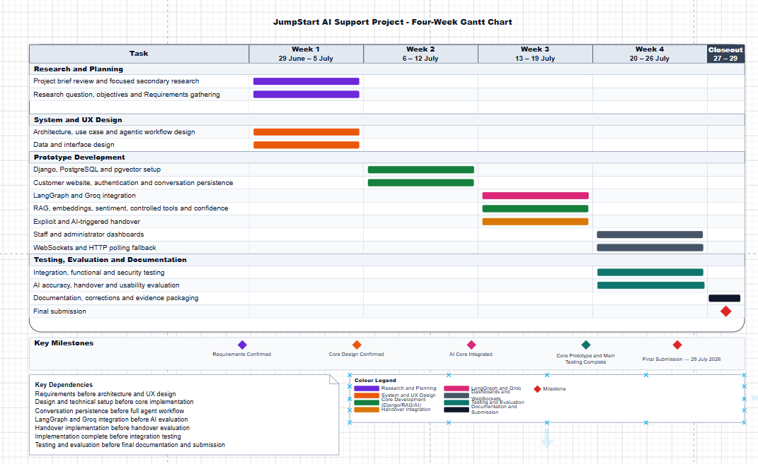
Figure 4. JumpStart AI Support Project - Four-Week Gantt Chart

10.1 Explanation of Figure 4
Gantt chart explanation
Week 1 (29 June-5 July) confirms requirements, and produces architecture, use-case, agentic workflow, data and interface designs. This creates the baseline required before implementation begins.
Week 2 (6-12 July) establishes Django, PostgreSQL, pgvector, authentication, the retail website and conversation persistence. These foundations are dependencies for the AI workflow and for later staff communication.
Week 3 (13-19 July) integrates LangGraph and Groq, RAG, embeddings, sentiment, approved tools, confidence logic and both handover routes. The milestone is a connected core prototype that can answer, clarify, verify and escalate.
Week 4 (20-26 July) completes staff and administrator dashboards, WebSockets, polling fallback, integration testing, security testing, answer-quality evaluation, handover evaluation and the three-participant usability exercise. The closeout period (27-29 July) is reserved for final documentation, corrections, evidence packaging and submission. The milestone and dependency notes show that testing must be completed before the final report is closed.

11. Expected Deliverables
- A completed research proposal and focused literature review.
- A locally running JumpStart retail website with registration, login and an authenticated customer-support chatbot.
- A single-agent LangGraph workflow using the Understand, Plan and Act, Verify and Route stages.
- RAG over approved JumpStart knowledge stored in PostgreSQL with pgvector.
- Local sentence embeddings, local sentiment analysis and deterministic confidence bands.
- Controlled Django tools for products, variants, mock orders, accounts, support cases and feedback.
- Validated explicit handover and separate AI-triggered handover.
- A support staff dashboard with waiting, active and resolved views, manual first acceptance, direct chat, return to AI and resolution.
- An administrator dashboard for users, permissions, knowledge approval, monitoring, errors and feedback review.
- Functional, integration, permission, security, RAG, routing, handover and usability evidence.
- Questionnaire results from approximately 20-30 participants and exploratory usability evidence from three participants.
- Screenshots, logs, test results, database backup or fixtures and a short recorded demonstration.
- A final report, evaluation and presentation materials.

12. Hardware and Software Requirements

12.1 Hardware
Hardware | Purpose and suitability
Windows 11 laptop | Primary development, local hosting, testing and demonstration environment.
NVIDIA GeForce GTX 1660 Ti with 6 GB VRAM | Suitable for compact local sentiment and embedding inference; the main LLM is hosted by Groq.
Internet connection | Required for Groq API, source control and academic-source access.
Local storage | Stores the project, PostgreSQL data, knowledge documents, backups, screenshots and evidence.
Additional browser/device where available | Allows simultaneous demonstration of customer, support staff and administrator views.

12.2 Software
Software or service | Role in the project
Visual Studio Code and Python | Development environment and programming language.
Django and Django REST Framework | Web application, authentication, permissions, APIs and controlled business logic.
PostgreSQL and pgvector | Relational data, conversation state, support cases, feedback, knowledge chunks and vector search.
LangGraph and LangChain integrations | Single-agent stateful workflow and connection to retrieval/tools/model services.
Groq API; initial configurable model openai/gpt-oss-20b | External language understanding and customer-friendly response drafting; availability rechecked before testing.
Hugging Face and Sentence Transformers | Compact local sentiment model and local embedding model.
Django Channels and WebSockets | Primary real-time customer-staff messaging and queue updates.
Tailwind CSS, HTMX, Alpine.js and JavaScript | Responsive and interactive browser interfaces.
Git and GitHub | Version control, backup and change history.
Postman | API and endpoint testing.
Draw.io | Creation and maintenance of the four selected proposal diagrams.
Microsoft Word and PowerPoint | Proposal/report formatting and final presentation.

13. Project Limitations and Future Enhancements

13.1 Limitations
Limitation | Effect on interpretation | Planned mitigation
Small questionnaire and three-person usability sample | Findings cannot be generalised to all retail customers. | Describe the study as exploratory and combine user evidence with technical testing.
Four-week implementation period | Complex features may compete for development time. | Freeze the core scope, use mock integrations and prioritise the complete AI-to-human workflow.
Local-only prototype | No evidence of public-cloud scalability or production availability. | Demonstrate reliably on local hardware and report cloud deployment as future work.
External Groq dependency | Model availability, limits or identifiers may change. | Keep the model configurable and recheck availability before testing and demonstration.
RAG retrieval errors | Weak or outdated evidence may produce an unsuitable answer. | Use approval, source metadata, relevance tests, verification, refusal and handover.
Sentiment and confidence misclassification | A case may escalate unnecessarily or fail to escalate. | Use multiple measurable signals, test thresholds and never use sentiment alone.
Simulated retail operations | The prototype does not prove real payment, refund, courier or inventory integration. | Label mock data clearly and avoid production claims.
English-only text interface | The prototype is less accessible to multilingual users and does not support attachments. | Record multilingual support and secure attachments as future enhancements.

13.2 Future Enhancements
- Public cloud deployment with production monitoring, secure secrets management and a managed database.
- Multilingual customer support and language-aware knowledge retrieval.
- Secure file and image attachments in customer-staff conversations.
- Automatic staff assignment using availability, skill, urgency and workload while retaining manual override.
- Real inventory, courier, payment, refund and loyalty integrations after security and organisational approval.
- A larger usability sample, longitudinal evaluation and comparison with an existing support process.
- Model and embedding comparison, improved retrieval reranking and more advanced structured knowledge.
- A multi-agent architecture only after the single-agent workflow has been validated and the additional coordination cost is justified.

14. Conclusion
This proposal defines JumpStart AI Support as a controlled hybrid customer-service system rather than an unrestricted chatbot. The business problem requires quick and consistent support, but it also requires protection against unsupported answers, misunderstood requests, sensitive situations and unsuitable automated actions. The proposed solution therefore combines grounded RAG, approved Django tools, a single LangGraph workflow, local sentiment and evidence-based confidence with immediate access to human staff.
The expected value for JumpStart Retail is a transparent prototype that automates suitable routine assistance without removing customer choice or human responsibility. The study will not claim production readiness or universal improvement. It will determine whether the design provides credible evidence of usefulness within the defined capstone scope and will identify the improvements needed for future development.

15. References
Han, K., Tang, L.A., Sun, R., Yuan, P., Cheng, W., Wang, H., Wang, W., Sun, Y. and Chen, H. (2026) ‘Structure-Aware RAG: Structured Retrieval Augmented Generation from Noisy Data for Conversational Agents’, arXiv:2605.24366. Available at: https://doi.org/10.48550/arXiv.2605.24366 (Accessed: 26 June 2026).
Huang, C., Jiang, Z., Zou, C., Lei, W. and Ng, S.-K. (2026) ‘Towards Proactive Information Probing: Customer Service Chatbots Harvesting Value from Conversation’, arXiv:2604.11077. Available at: https://arxiv.org/abs/2604.11077 (Accessed: 26 June 2026).
Wang, Y., Zhu, C., Feng, T., Lu, L.X. and Jia, B. (2026) ‘Agentic AI and Human-in-the-Loop Interventions: Field Experimental Evidence from Alibaba’s Customer Service Operations’, arXiv:2605.14830, version 2. Available at: https://doi.org/10.48550/arXiv.2605.14830 (Accessed: 26 June 2026).

